Till now we have been working on creation and destruction of infrastructure senarios.
Eg: We created a web-server EC2 instance with terraform.
Problem: it’s only an EC2 instance, it does not have any software installed.
Provisioners are used to execute scripts on a local or remote machine as part of resource creation or destruction.
Eg: On creation of Web-Server, execute a script which installs Nginx web-server.
While creating of EC2 instance gets created, the terraform should also automatically go ahead and install the nginx Web-Server.
Types of Provisioners:
There are 2 types of provisioners
- Local-exec
- Remote-exec
Tf has capability to turn provisioners both at the time of resource creation as well as destruction.
Local-exec:-
Local-exec provisioners allow us to invoke local executable after resource is created.
Eg:
Resource “aws_instance” “ web” {
#...

Provisioner “local-exec” {
Command = “echo ${aws_instance.web.private_ip} >> private_ips.txt”
}
}
The above script will execute the provided the command in local machine.
It’s very powerful tool.
Remote-exec:- Remote-exec provisioners allow to invoke scripts directly on the remote server.
Eg:
Resource “aws_instance” “web” {
#...
Provisioner “remote-exec” {
Command = “…..”
}
}
From above script it will execute the command on remote server.
Like these provisioners we have few more provisioners like chef ,salt etc. Pls check TF docs in website.
Implementing remote-exec provisioners
The remote-exec provisioner invokes a script on a remote resource after it is created.Before going to use TF script. We will take one example and we will see what are all steps involved if we do it manually.
Eg:-
Assume we are going to create a nginix server. Steps to achieve are below:
- First we need to create an ec2 instance, for that we need to create a new key along with that we need to allow ports in inbound rule in SG. Here port is 80 for nginx.
- After creation of EC2 we will install the nginx and we will start the nginx by using systemctl command.
- Finally we will check the server is up and running on browser.
To achieve above steps automatically we will write the TF script.
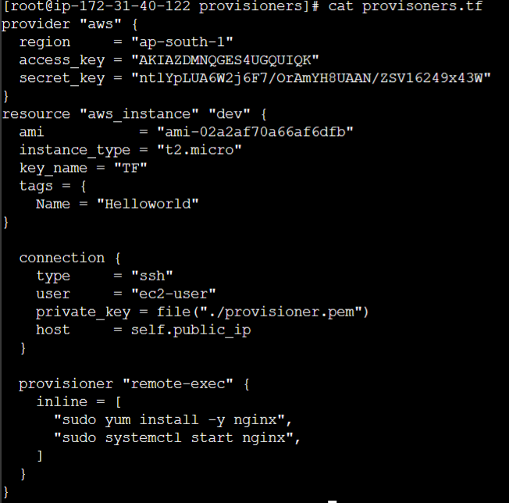
From above script we will create the nginx web server.
If we analyse the above script. The provider and resource will be same. Additionally added connection and provisioner. To get this go to google search for remote-exec in terraform the result will lead to TF website(Provisioner: remote-exec | Terraform | HashiCorp Developer).
From there we will add connection and resource.
Connection :-is mainly for, after creating the ec2 instance we need to login to the instance to execute certain commands for that we use connection.
To login to the server we need either ppk/pem key file. Here we are using .pem file. I have created a .pem file first and copied it to the local machine where my provisioner.tf script is there.
In connection we have to mention the private key for that we need to go to provisioner connections page in TF (Provisioner Connection Settings | Terraform | HashiCorp Developer). From mentioned page we can define the private key variable that is variable_key . By giving variable_key as a variable it would be fine. But to define value we need to mention the file and it’s path, because we are using .pem file to define that we use file module.
Private_key = file(“./provisioner.pem”)
We need to mention key_name along with the private_key. The key_name is the one which we created the .pem file name in AWS console. The key_name will be configures under connection.
Provisoner For provisioner we are defining to remote-exec and in the inline we are going to mention the commands. It will look like below.
Provisioner “remote-exec” {
Inline = [
“sudo yum install -y nginx”,
“sudo systemctl start nginx”
]
}
So after login into the instance with the help of connection, the provisioner will run the commands on the instance.
Note:- Here to run nginx we need port 80 to be allowed in the SG inbound rules. But in our script we are not defining any SG. If we don’t define any SG, the TF will take default SG. So for default SG the inbound rules should be configured.
Implementing local-exec provisioners

Local-exec provisioners allows us to invoke a local executable after the resource is created.
One of the most used approach of local-exec is to run ansible-playbooks on the created server after the resource is created.
Provisioner “local-exec” {
Command = “echo ${aws_instnance.web.private_ip} >> private_ips.txt”
}
Local executioner basically executes this local exectable, which is running in the workstation were your TF has been invoked. It will run the code where the TF machine has been invoked from.
We didn’t execute this command. For more info refer this link Provisioner: local-exec | Terraform | HashiCorp Developer .
Provisioner types
There are two primary types of provisioners:
Types of Provisoners | Descriptin
Creation-time Provisioner | Creation-time provisioners are only run during creation, not during updating or any other lifecycle  If a creation-time provisioner fails, the resource is marked as as tainted
Destroy-Time Provisioner | Destroy provisioners are run before the resource is destroyed

The below script is used for both the provsioners
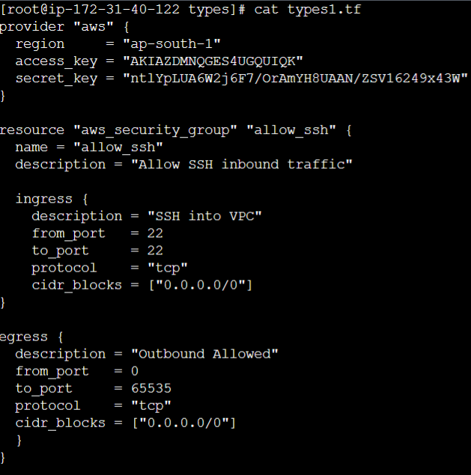
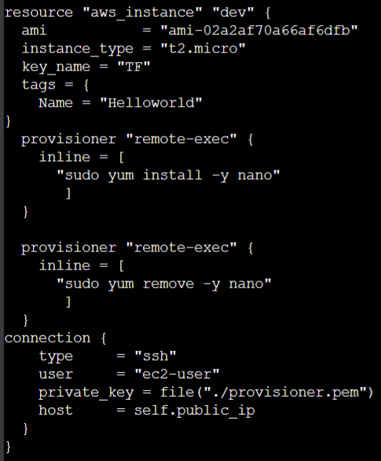
Create-time provisioner: The below SS is creation time provision.
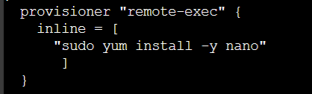
Destroy-time Provisioner: The below SS is destroy time provision.
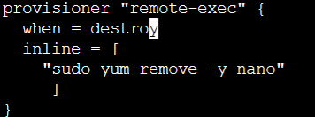
When we run terraform apply command it will execute the creation-time provision.
When running terraform destroy it will execute destroy-time provision. What it will do is, first it will uninstall the service and then it will terminate the instance. Usually we use it in Prod env to uninstall the anti-virus.
Tainted: If a creation-time provisioner fails, the resource is marked as tainted.
So to check this we intentionally remove the egress rule. When we remove it the sudo yum install nano command will not work because due to no internet connection. But still ec2 instance will be crated having SG without outbound rule.
So in terraform state file it will show the “status”:tainted. If you do terraform plan it will display one to destroy one to add and in the log also it will show that #aws_instance.myec2 is tainted, so must be replaced.
Failure Behaviour-Provisioners
By default, provisioners that fail will also cause the Terraform apply itself to fail. In earlier session for Creation-time provisioner we observed the tainted one. If the provisioner is failed then automatically the resource is marked as tainted.
So, If you want to skip/ignore the tainted one. We will use on_failure. The on_failure setting can be used to change this. The allowed values are:
Allowed Values | Description
continue | Ignore the error and continue with creation or destruction
Fail | Raise an error and stop applying (the default behaviour). If this is a creation provisioner, taint the resource.
Eg:
Resource “aws_instance” “aws” {
#...
Provisioner “local-exec” {
Command = “ echo ‘server’s IP address is ${self.private.ip}’”
On_failure = continue
}
}

